Lab 7.1 Allow multiple task entries in the Task Manager app

In this application, you’ll make an enhancement that allows you to enter multiple tasks separated by commas in a single entry.

Here is the enhanced application, with multiple tasks about to be entered:

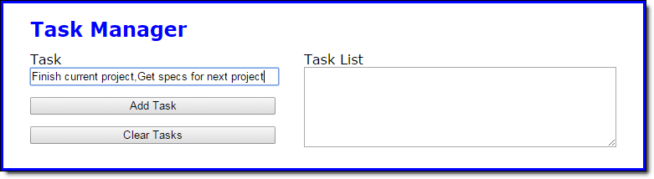

And here is the application after the multiple tasks have been entered:

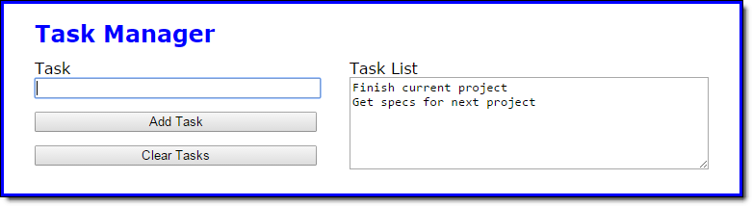

1. Open the HTML and JavaScript files in this folder
2. Run the application and add two tasks, separated by a comma. Note that the tasks are stored as one task, exactly as you entered it.
3. In the JavaScript file, find the code in the addToTaskList function that adds the task entered by the user to the tasks array. Comment out that code, and replace it with code that works for one task in an entry and also for more than one task in an entry.

To do that, you can use the split method of the String object to convert the user’s entry into an array.

<http://www.w3schools.com/jsref/jsref_split.asp>

You can use the concat method of the tasks array to add the new tasks to the tasks array.